# Marketplace Test Report (Mobile View):

1.Login - Text in Placeholder, The Placeholder is fixed, and text is being overlapped (this is for the first login of a user).

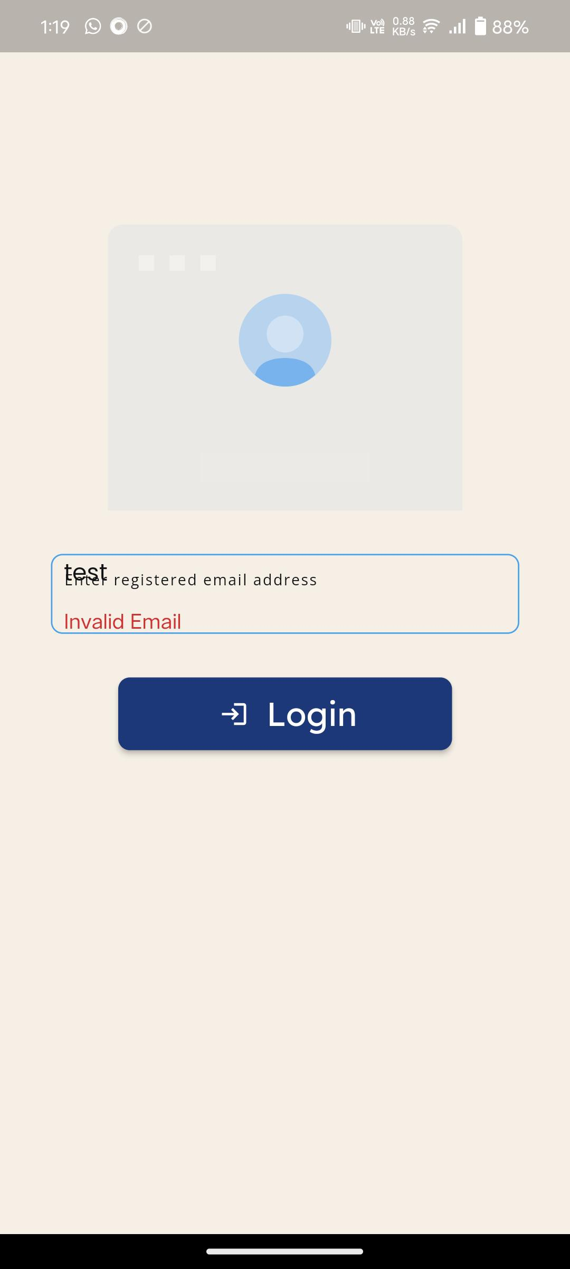

1. Login - Color Scheme in Day and Night Mode - In Night Mode, the text color is white, which is not visible to the user.
2. For the Complete App - Color Scheme in Day and Night Mode - In Night Mode, the text color is white, and the font and size are not visible to the user for input and labels.

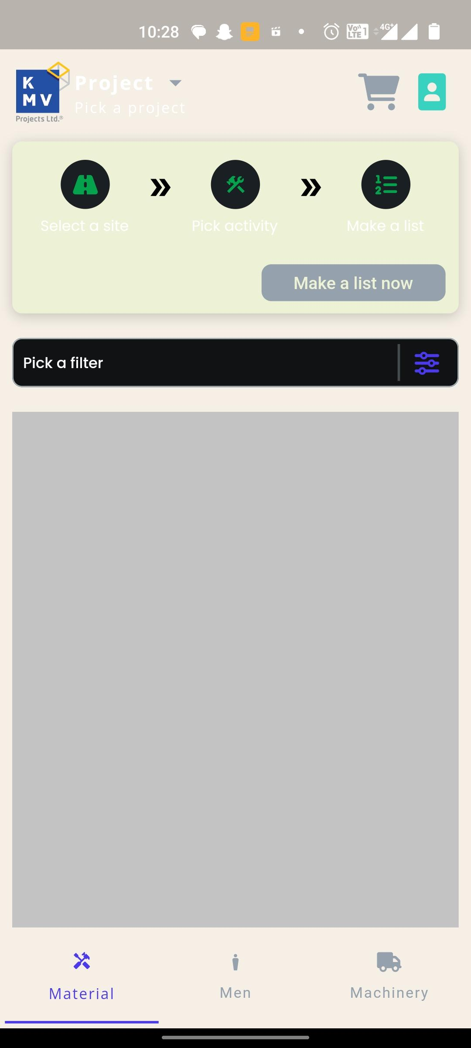

1. The design is not responsive.

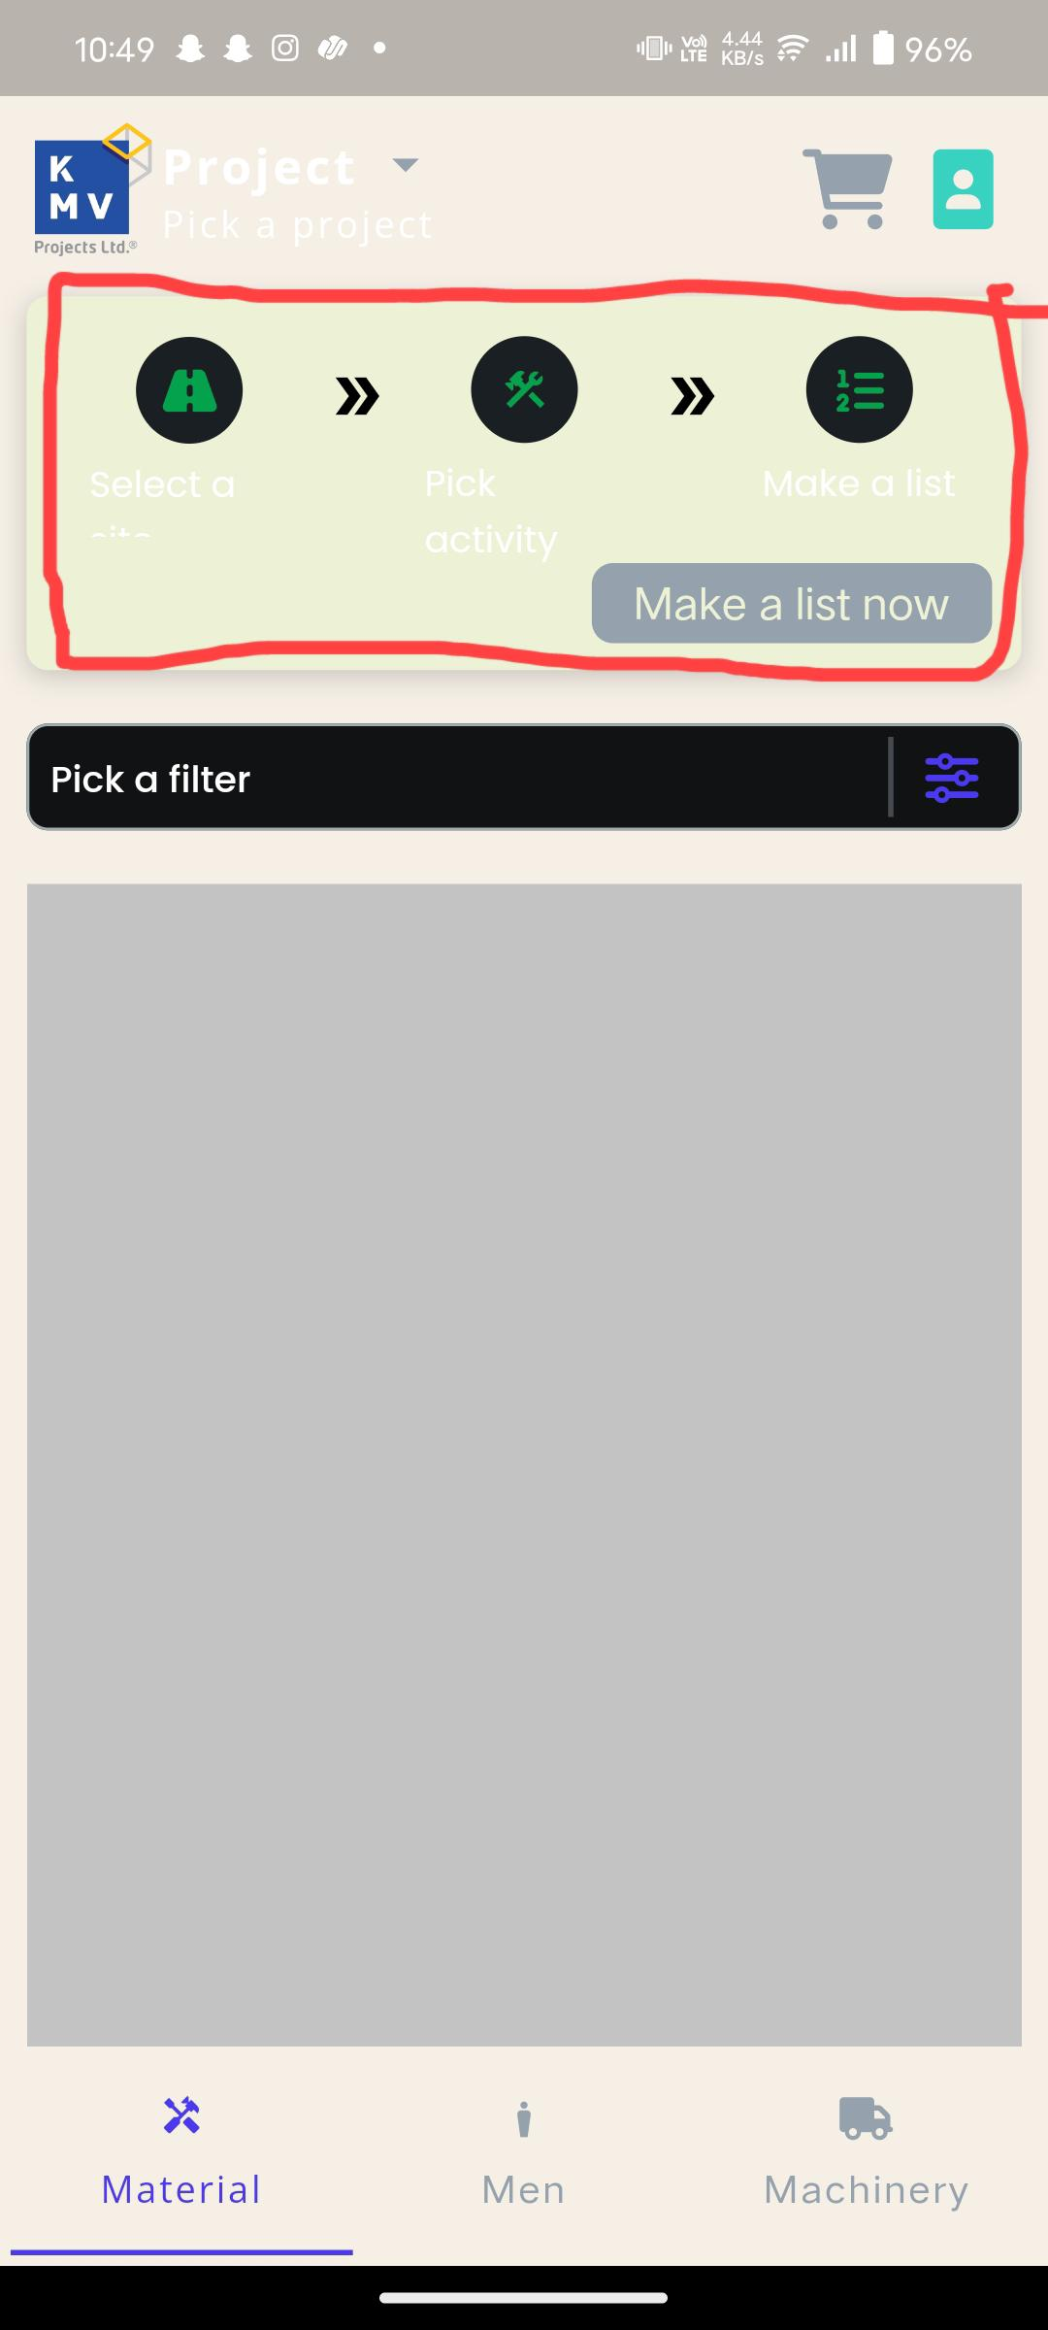

1. During the Selection of Item - While selecting Date & Time, there is no Time field to select (if not necessary, remove the label and just ask the user to select the date).

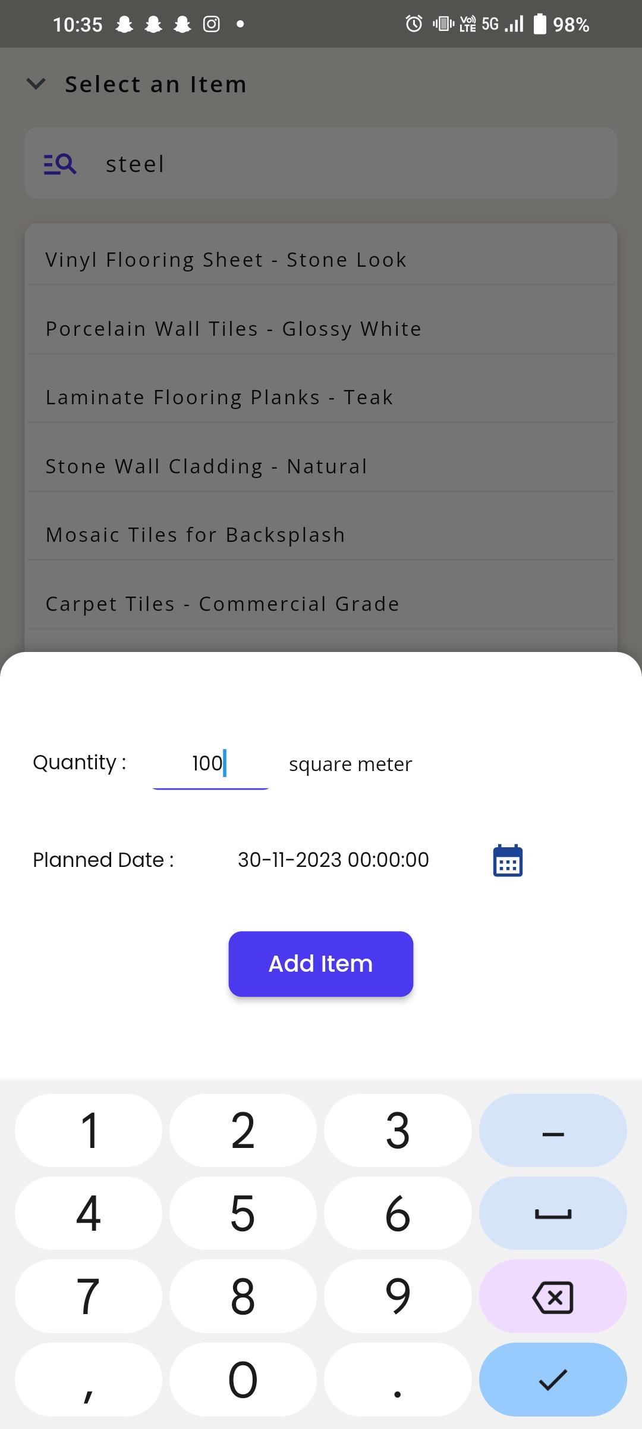

1. Error Message - There are no error messages while giving input / modifying the mandatory fields (this error message is not working for date and time).

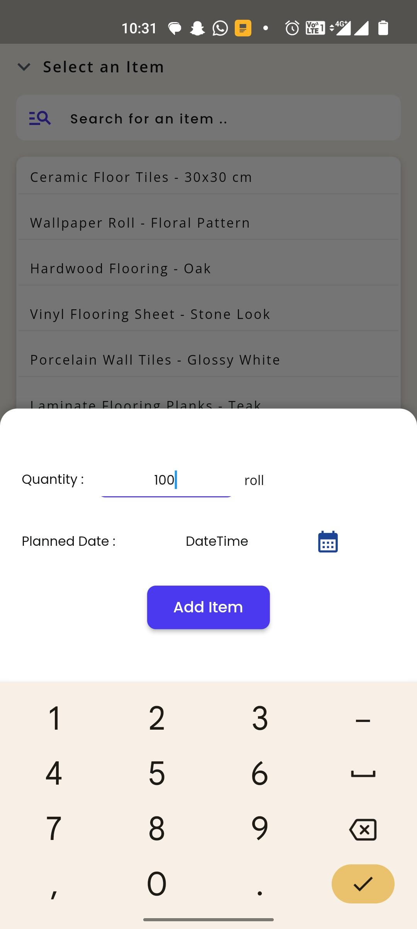

1. Text Alignments - The text alignment is not responsive from mobile to mobile and for item description length.

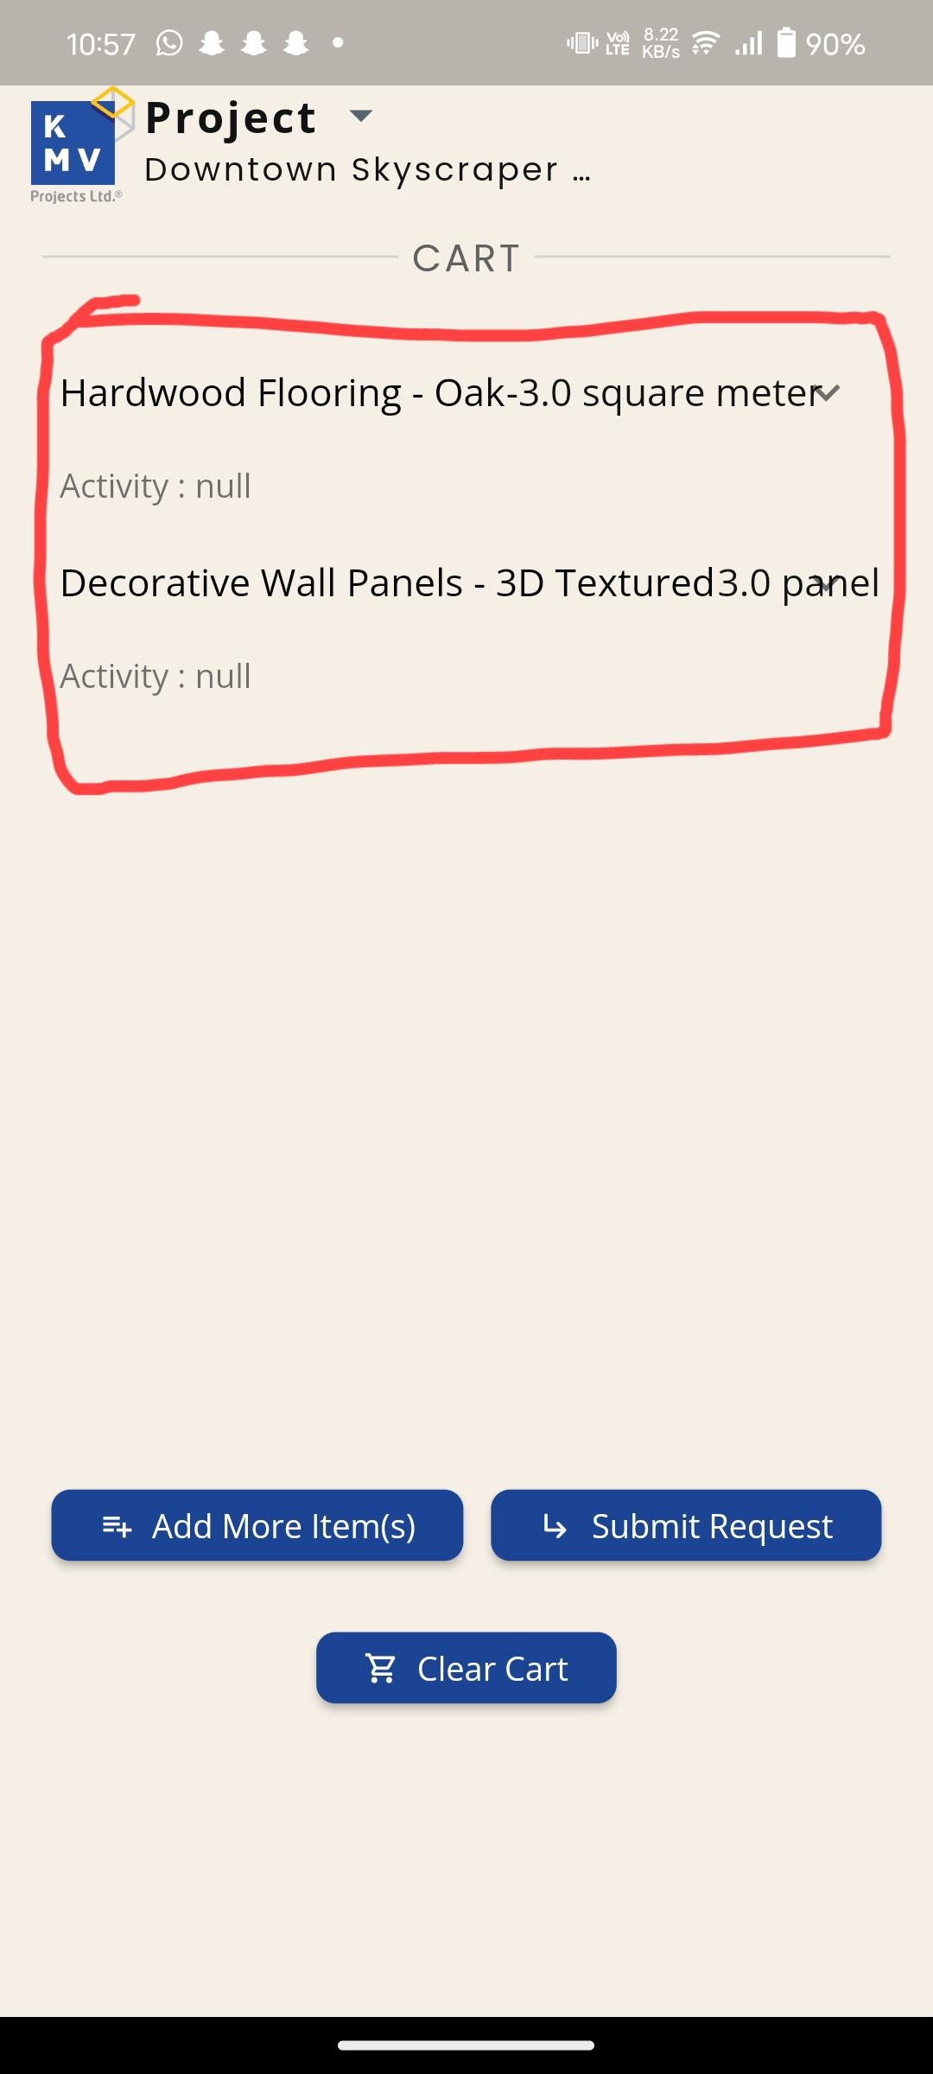

1. In Cart - Even after selecting Warehouse, Activity, in the cart, the details are shown as NULL. There is no option to select Category, yet it is shown in the Cart List.

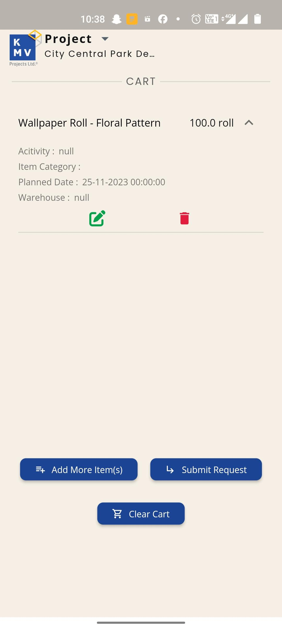

1. In Filters - While selecting Warehouse option, the system is automatically selecting Status also, and the Clear button is not working properly for the same selection option.

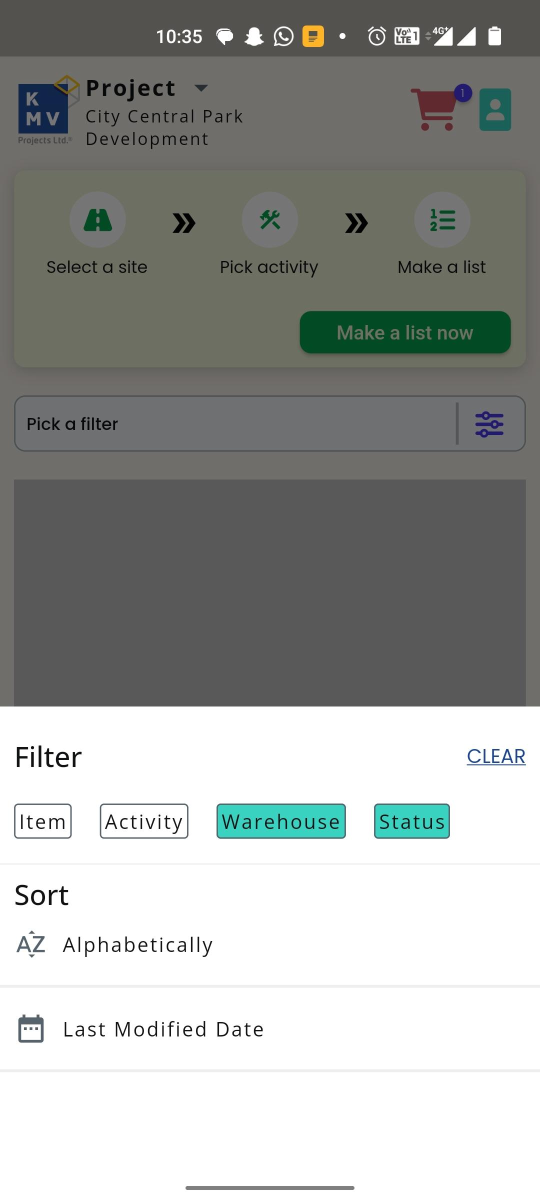

1. In Filters - Options like Requested, Clarification, etc., are not working. Yet, when selected, the Rejected options - the screen is popped up with the color picker.

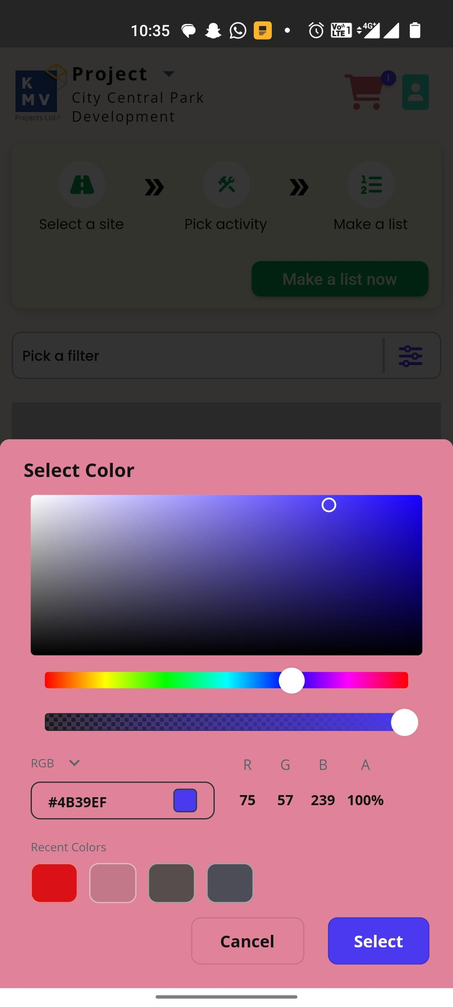

1. Validations while selecting Activity, Warehouse - The validation is being done even with 1 character entered, while the mandatory is shown as 2 characters.

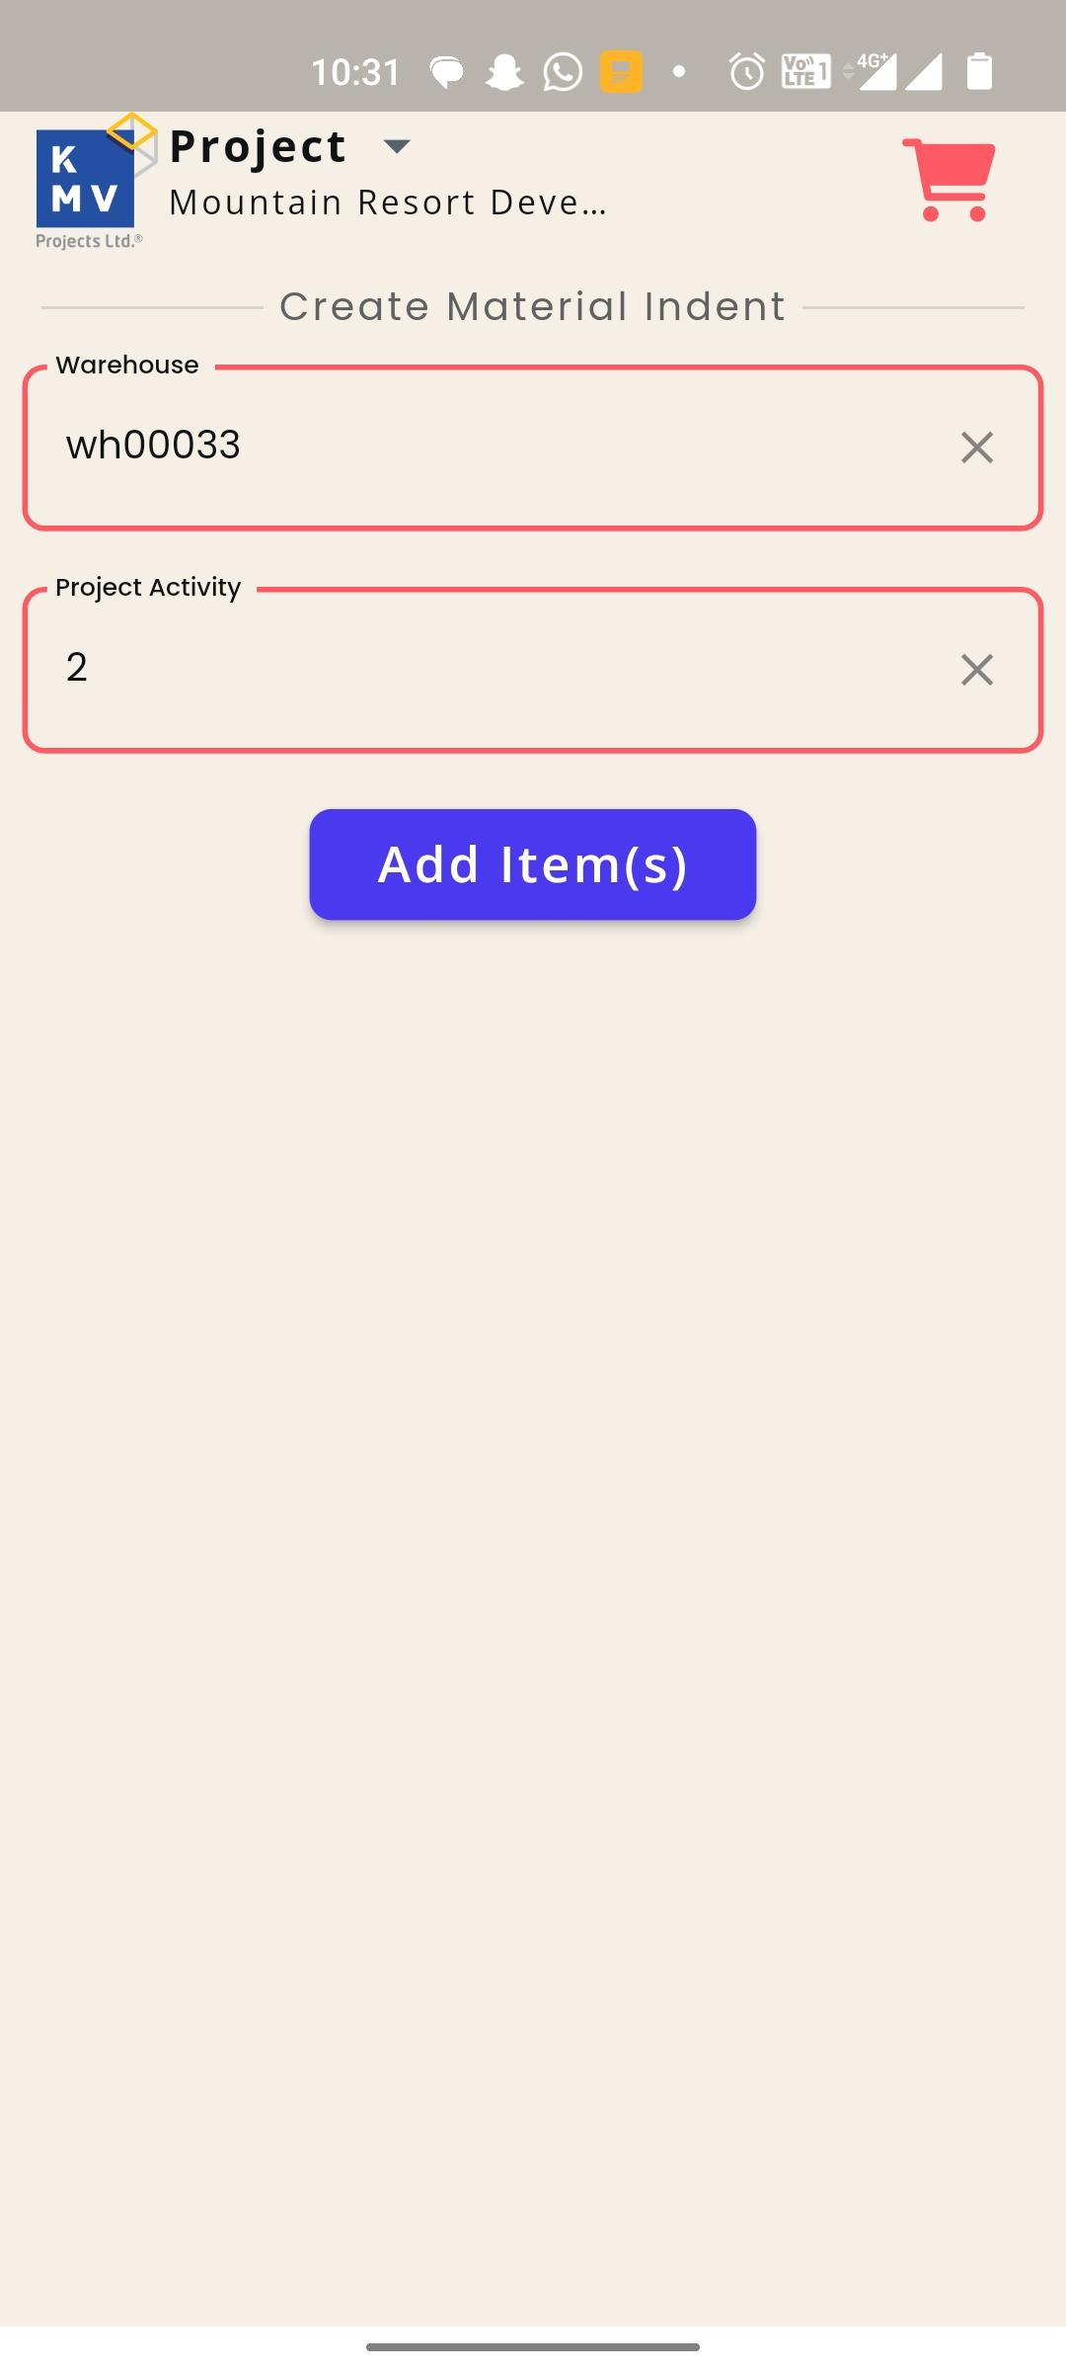

1. Addition of Item - Can we show a popup message when adding an item; the user is unable to identify whether the item is added unless he looks at his cart.

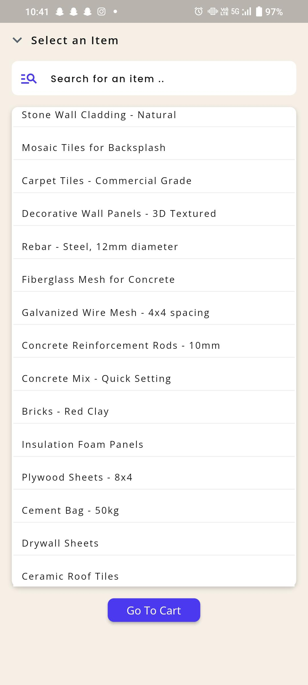

1. Item Selection List - The search filter in the item selection is not working.

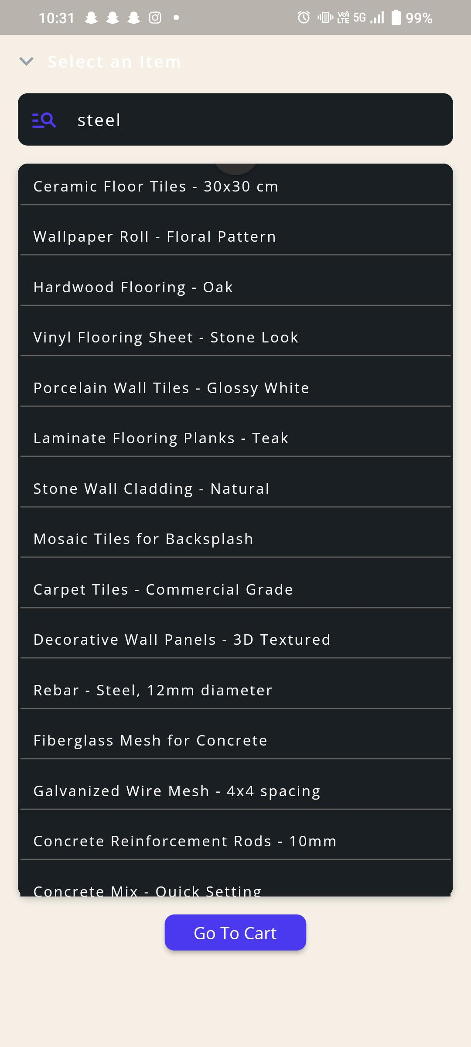

1. Selection of Other Projects - While the user is adding items to the cart, the user can change the project name. This should not be the case unless the user wants to switch the project; it has to happen on the home screen and not on the various items adding screen.

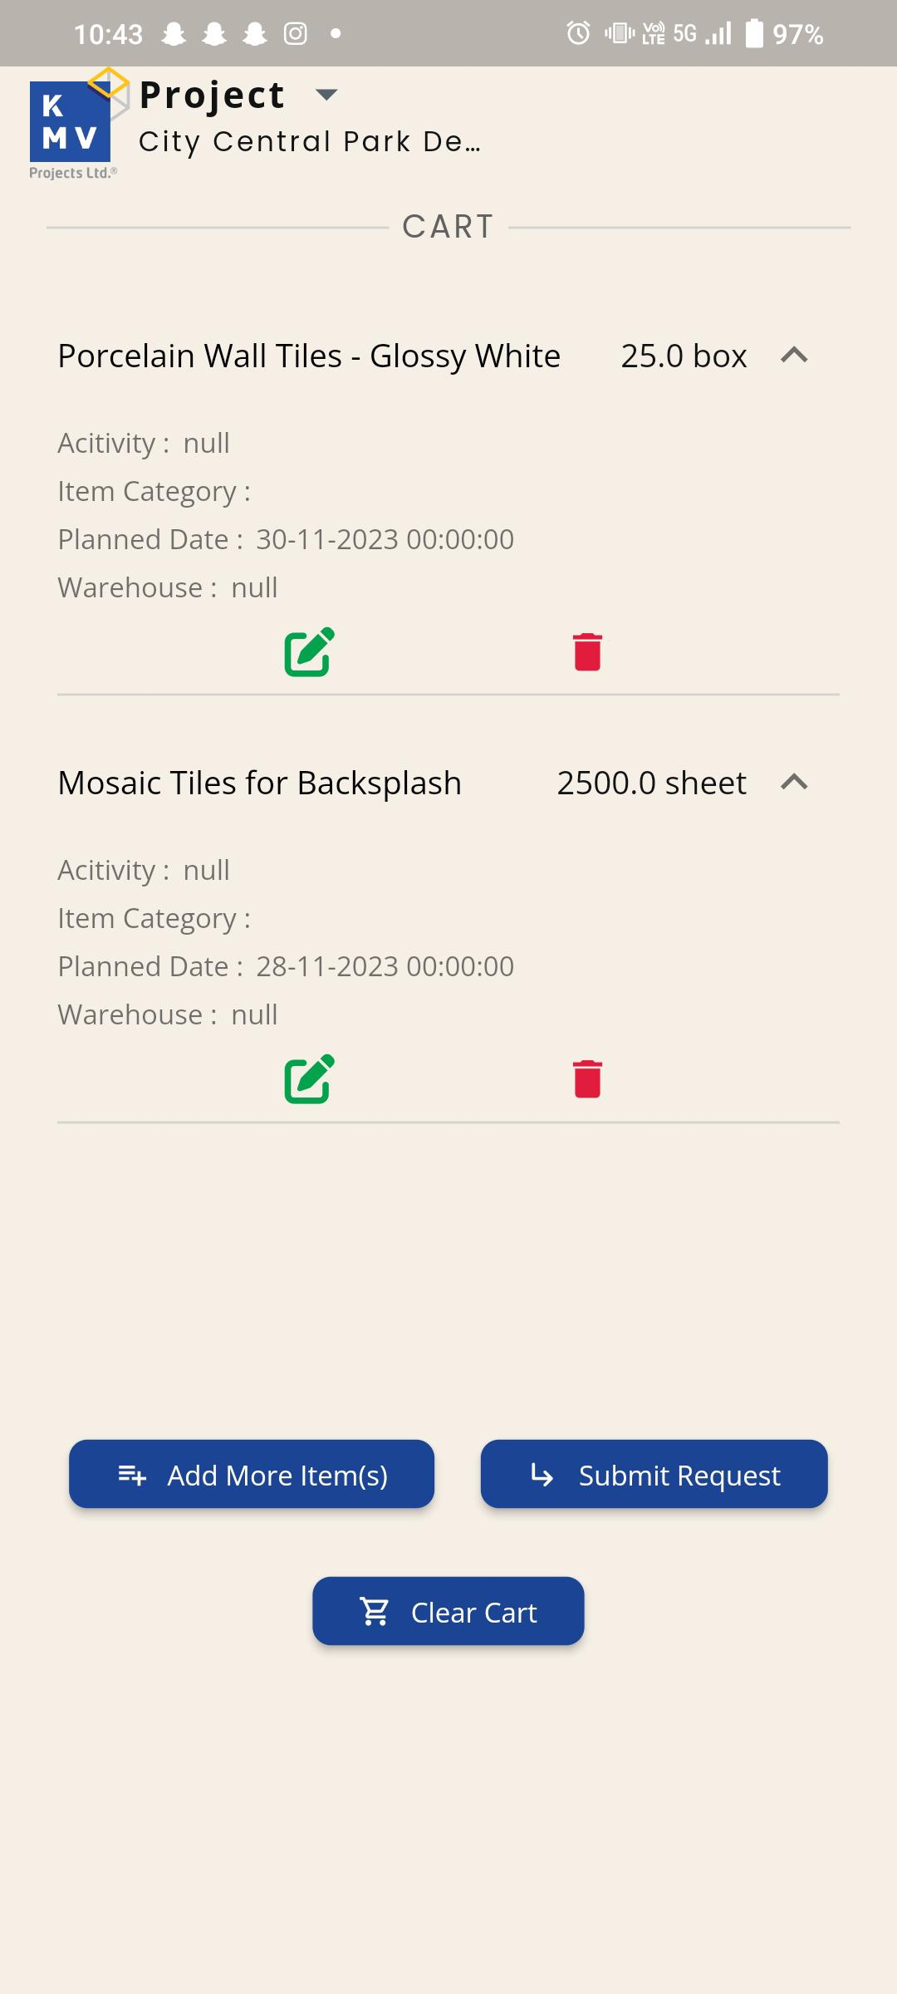 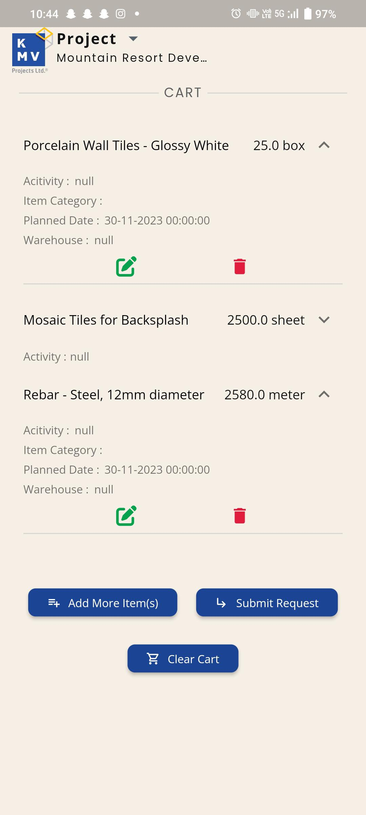

1. In Home Screen - Can we highlight the project once the user selects a project to indicate the process and steps? This is for a better user experience.



1. Increase the icon size i.e., :(Materials, Men, machinery).

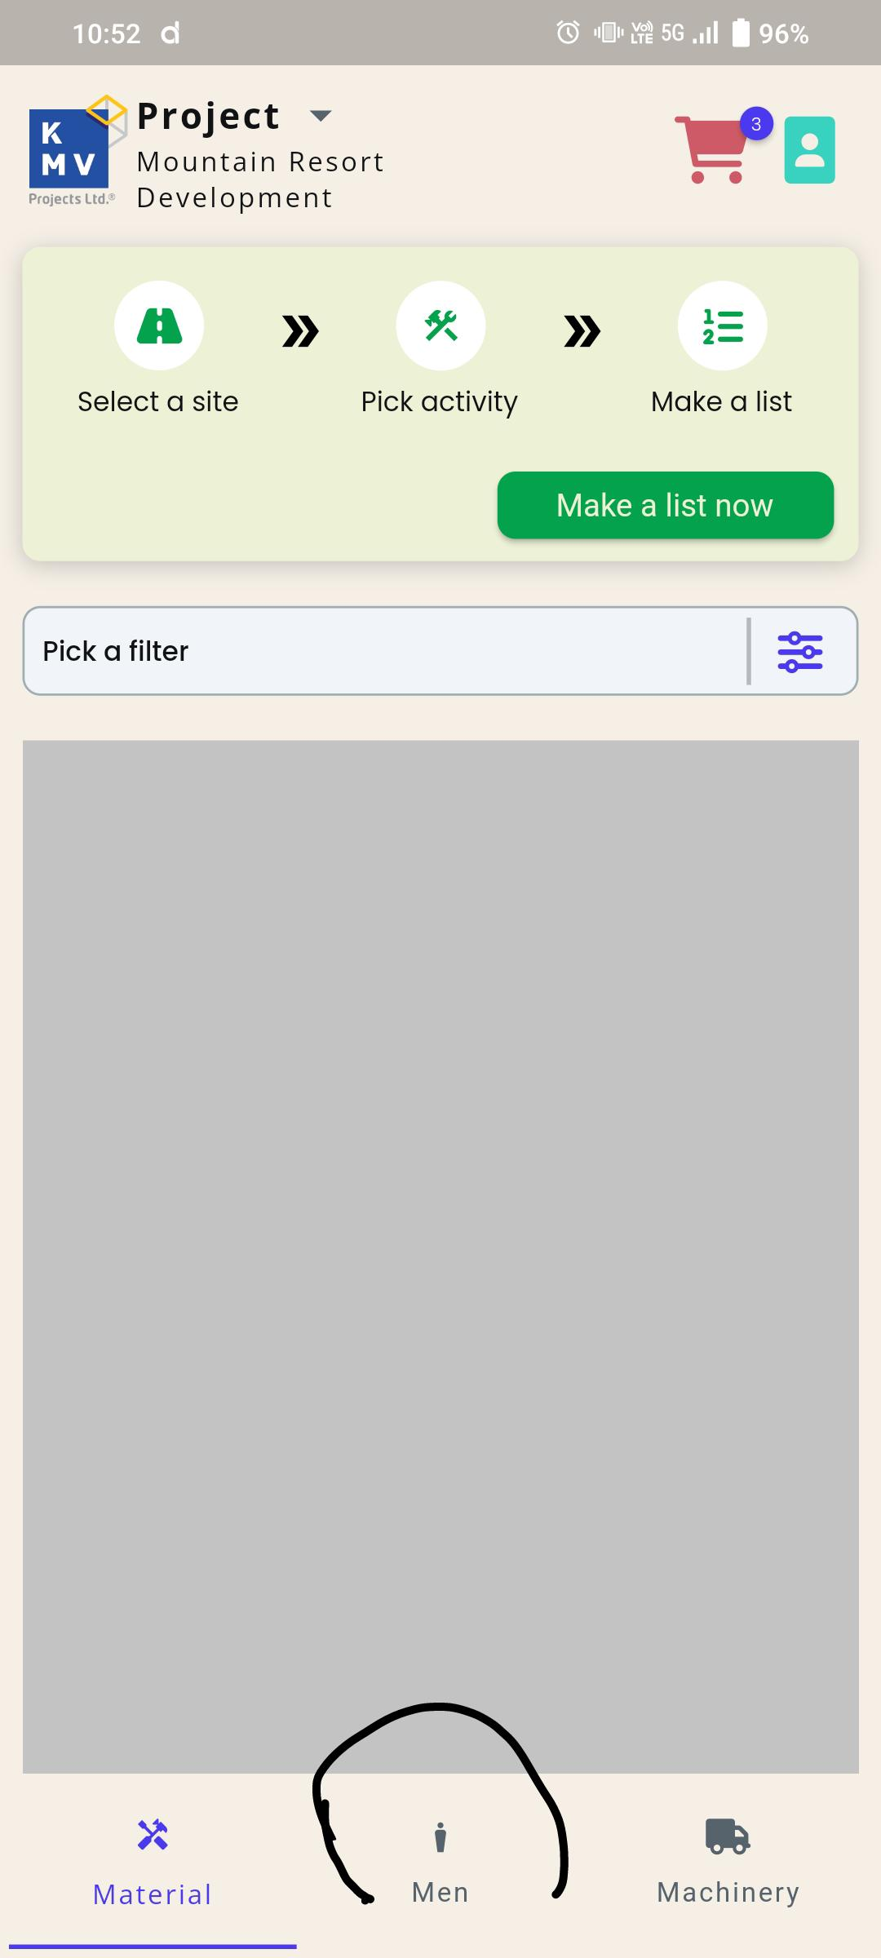

1. in the account details Assigned projects and warehouse tagged button are not working.

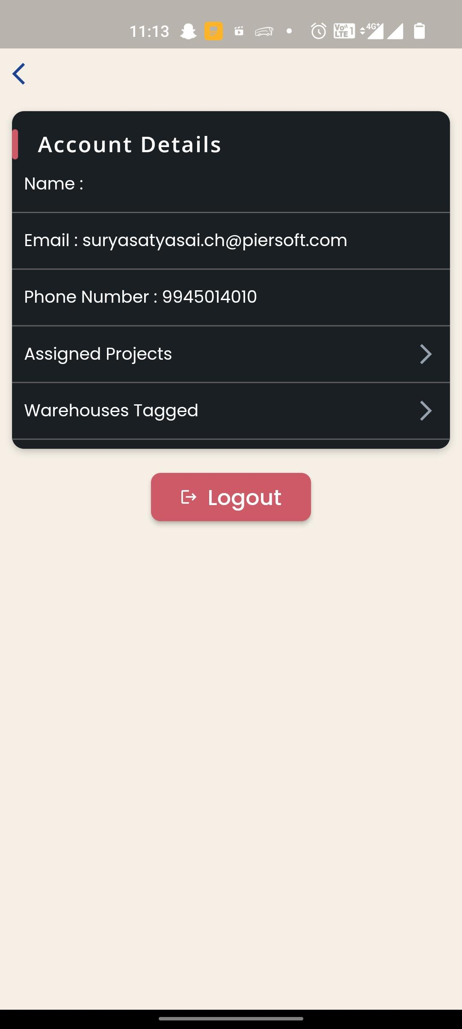

18.There appears to be a considerable amount of space in the first tab, and the list does not display any information.

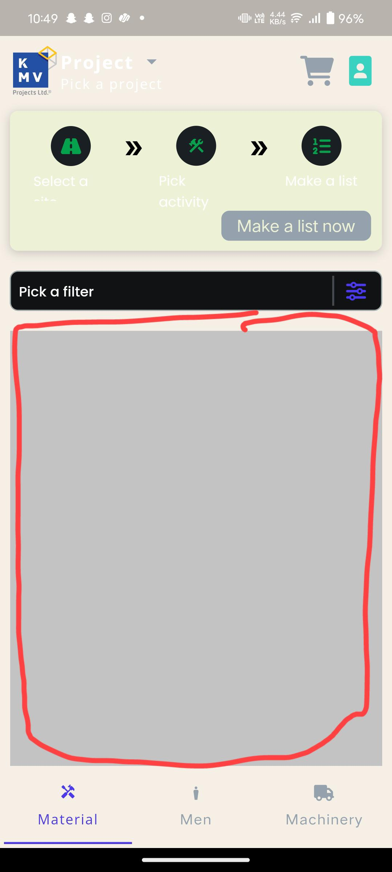

19.OTP: Re-sending OTP verification has failed; the error message should be displayed prominently.  
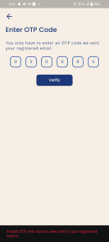

20.Enter OTP Code Tab: The back arrow in screen is unresponsive when clicked.

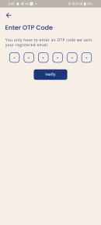

21.Error Message: Increase the time duration of popup messages.



22.Email: While editing the input field, the cursor is positioned incorrectly.  
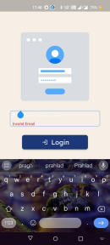

23.Cart Page (Add more items): If more items are added to the cart and it reaches the bottom of the page, the view details are not displayed until the page is scrolled.

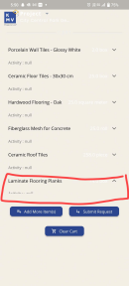

24.Add item: Negative quantity should not be allowed.

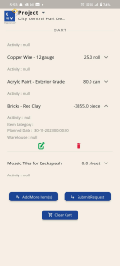

25.Add item: Without selecting any item, when clicking "Add item," if we open "Go to cart," the submission request is working.

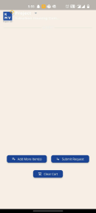 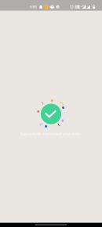

26.Add item: Quantity should be in numbers only and greater than zero.

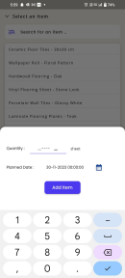 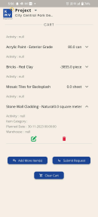

27. "In the Cart: While modifying the existing data for an item, updating the quantity changes the planned date to datetime (01-01-2023)."

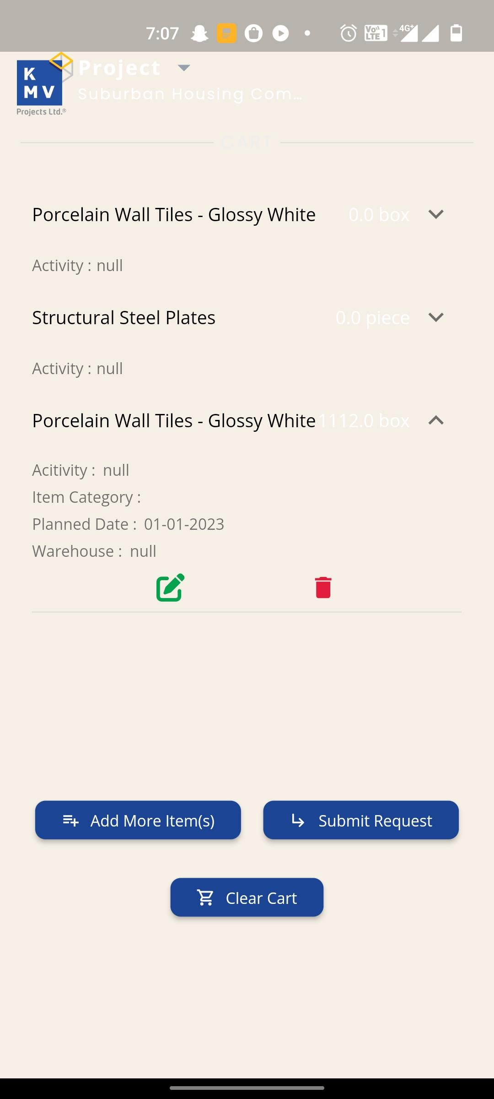

28.After clicking on 'Edit,' if we click 'OK' without making any modifications, the quantity is changed to zero.

